Lab # 1
INTRODUCTION TO OOP

OBJECTIVE:

To understand OOP(Java Environment),Data Types and Mixed Arthematic Expression.

THEORY:

DEFINITION OF OOP IN JAVA
OOP concepts in Java are the main ideas behind Java’s Object-Oriented Programming. They are an abstraction, encapsulation, inheritance, and polymorphism. Grasping them is key to understanding how Java works. Basically, Java OOP concepts let us create working methods and variables, then re-use all or part of them without compromising security.

Basic Terminologies:

Object:
It’s the instance of a class/ it’s the working entity of a class.

Class:
It is a template or blueprint about the capability of what an object can do.

Method:
The behaviors of a class. It tells what a method can do.

Instance:
Object and Instance both are same with small difference.

1.2 CONCEPT OF OOP

OOPs (Object-Oriented Programming System):
Object means a real-world entity such as a pen, chair, table, computer, watch, etc. Object-Oriented Programming is a methodology or paradigm to design a program using classes and objects. It simplifies software development and maintenance by providing some concepts:

- Object Class
- Inheritance
- Polymorphism
- Abstraction
- Encapsulation

1.3 HOW TO CREATE AND USE CODE:
To create an IDE project:
- Start NetBeans IDE.
- In the IDE, choose File > New Project, as shown in the figure below.
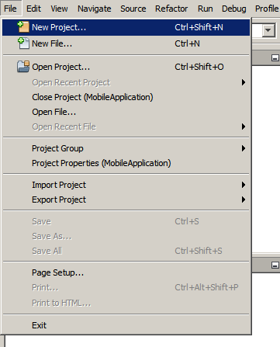
- In the New Project wizard, expand the Java category and select Java Application as shown in the figure below. Then click Next.
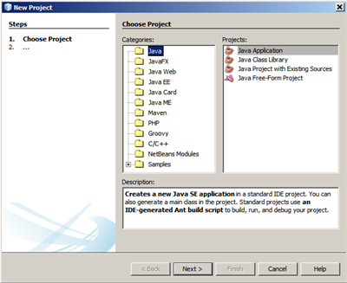
- In the Name and Location page of the wizard, do the following (as shown in the figure below):
  - In the Project Name field, type HelloWorldApp.
  - Leave the Use Dedicated Folder for Storing Libraries checkbox unselected.
  - In the Create Main Class field, type helloworldapp.HelloWorldApp.

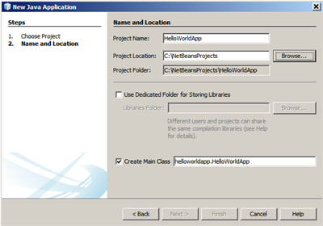

- Click Finish.
The project is created and opened in the IDE. You should see the following components:
- The Projects window, which contains a tree view of the components of the project, including source files, libraries that your code depends on, and so on.
- The Source Editor window with a file called HelloWorldApp open.
- The Navigator window, which you can use to quickly navigate between elements within the selected class.
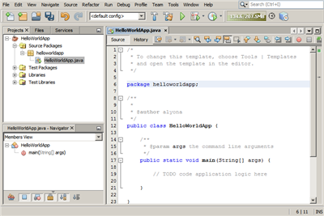

Adding Code to the Generated Source File:
Because you have left the Create Main Class checkbox selected in the New Project wizard, the IDE has created a skeleton main class for you. You can add the "Hello World!" message to the skeleton code by replacing the line:
// TODO code application logic here

with the line: System.out.println("Hello World!");
Save the change by choosing File > Save.

The file should look something like the following code sample.

/*
* To change this template, choose Tools | Templates
* and open the template in the editor.
*/

package helloworldapp;

/**
*
* @author <your name>
*/
public class HelloWorldApp {

/**
* @param args the command line arguments
*/
public static void main(String[] args) {
System.out.println("Hello World!");
}

}

Compiling and Running the Program:
Because of the IDE's Compile on Save feature, you do not have to manually compile your project in order to run it in the IDE. When you save a Java source file, the IDE automatically compiles it.
The Compile on Save feature can be turned off in the Project Properties window. Right-click your project, select Properties. In the Properties window, choose the Compiling tab. The Compile on Save checkbox is right at the top. Note that in the Project Properties window you can configure numerous settings for your project: project libraries, packaging, building, running, etc.
To run the program:
- Choose Run > Run Project.
The next figure shows what you should now see.
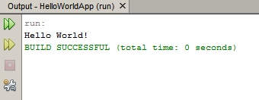
Congratulations! Your program works!
If there are compilation errors, they are marked with red glyphs in the left and right margins of the Source Editor. The glyphs in the left margin indicate errors for the corresponding lines. The glyphs in the right margin show all of the areas of the file that have errors, including errors in lines that are not visible. You can mouse over an error mark to get a description of the error. You can click a glyph in the right margin to jump to the line with the error.

Building and Deploying the Application:
Once you have written and test run your application, you can use the Clean and Build command to build your application for deployment. When you use the Clean and Build command, the IDE runs a build script that performs the following tasks:
- Deletes any previously compiled files and other build outputs.
- Recompiles the application and builds a JAR file containing the compiled files.
To build your application:
- Choose Run > Clean and Build Project.
You can view the build outputs by opening the Files window and expanding the HelloWorldApp node. The compiled bytecode file HelloWorldApp.class is within the build/classes/helloworldapp subnode. A deployable JAR file that contains the HelloWorldApp.class is within the dist node.
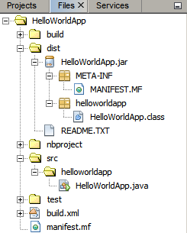
You now know how to accomplish some of the most common programming tasks in the IDE.

1.4 JAVA DATA TYPES

Java defines eight simple (or elemental) types of data: byte, short, int, long, char, float, double, and boolean. These can be put in four groups:

- Integers: This group includes byte, short, int, and long, which are for whole valued signed numbers.

- Long: It is a signed 64-bit type and is useful for those occasions where an int type is not large enough to hold the desired value.

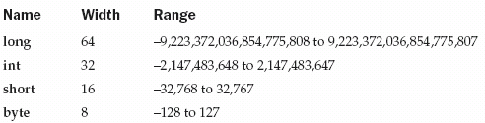
Integers

- Floating-point numbers: This group includes float and double, which represent numbers with fractional precision.

Floating-Point Types

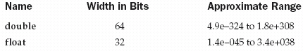

- Double: The double variable can hold very large (or small) numbers. The maximum and minimum values are 17 followed by 307 zeros.
Here is a short program that uses double variables to compute addition.

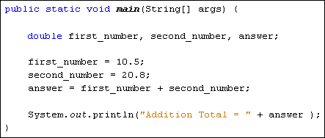

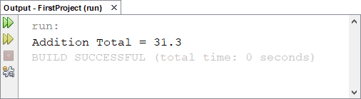

- Characters: This group includes char, which represents symbols in a character set, like letters and numbers.

- Boolean: This group includes boolean, which is a special type for representing true/false values. Following Java program that flips boolean value.

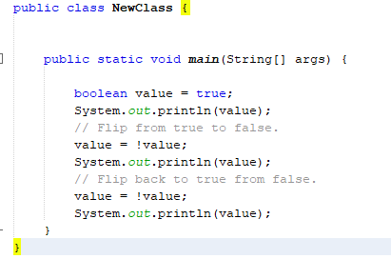

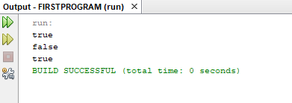

1.5 MIXED ARITHMETIC EXPRESSIONS

Explicit Casting
Type Casting in Java is nothing but converting a primitive or interface or class in into other type. There is a rule in Java Language that classes or interface which shares the same type hierarchy only can be type casted. If there is no relationship between then Java will throw ClassCastException. Type casting are of two types they are
- Implicit Casting (Widening)
- Explicit Casting (Narrowing)

Implicit Casting in Java / Widening / Automatic type conversion
Automatic type conversion can happen if both type are compatible and target type is larger than source type.

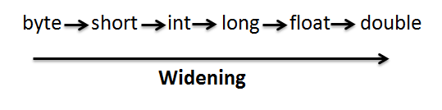
Example:
No Explicit casting required for the above mentioned sequence.
public class Implicit_Casting_Example
{
public static void main(String args[])
{
byte i = 50;
// No casting needed for below conversion
short j = i;
int k = j;
long l = k;
float m = l;
double n = m;

System.out.println("byte value : "+i);
System.out.println("short value : "+j);
System.out.println("int value : "+k);
System.out.println("long value : "+l);
System.out.println("float value : "+m);
System.out.println("double value : "+n);
}
}
Output :
byte value : 50
short value : 50
int value : 50
long value : 50
float value : 50.0
double value : 50.0

Explicit Casting in Java / Narrowing
When you are assigning a larger type to a smaller type, then Explicit Casting is required
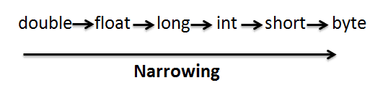
Example:
public class Explicit_Casting_Example
{
public static void main(String args[])
{
double d = 75.0;
// Explicit casting is needed for below conversion
float f = (float) d;
long l = (long) f;
int i = (int) l;
short s = (short) i;
byte b = (byte) s;

System.out.println("double value : "+d);
System.out.println("float value : "+f);
System.out.println("long value : "+l);
System.out.println("int value : "+i);
System.out.println("short value : "+s);
System.out.println("byte value : "+b);
}
}
Output :
double value : 75.0
float value : 75.0
long value : 75
int value : 75
short value : 75
byte value : 75

LAB TASK

1.Write a Java program that reads a number in inches, converts it to meters.
Note: One inch is 0.0254 meter.
Example:
Test Data
Input a value for inch: 1000.
Expected Output:
1000.0 inch is 25.4 meters.

2.Write a Java program to convert days into number of months and days.
Example:
Test Data
Input the number of days: 69.
Expected Output:
69 days are 2 months and 9 days.

3. Write a Java program to compute body mass index (BMI).
Note: weigh in kilogram = weight * 0.45359237.
Hight in feet= inches * 0.0254.
BMI= weight in kilogram/(hight in fee)^2.

